CASE STUDY:
MAPPING CONTRIBUTIONS & CONNECTIONS
The UN’s Sustainable Development Goals (SDGs) and IUPUI

The Indiana University-led AMPATH Consortium, the AMPATH Research Network, IU Center for Global Health and the Indiana University School of Medicine

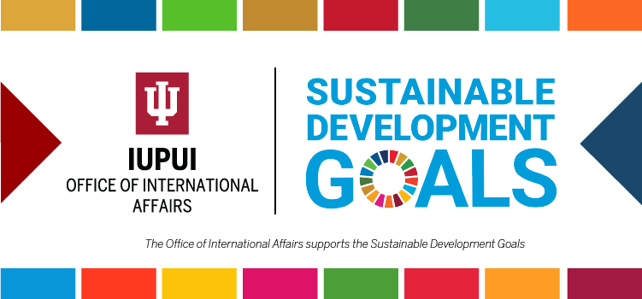

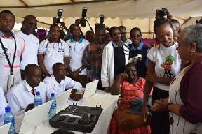 |  | 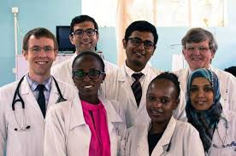 |  | 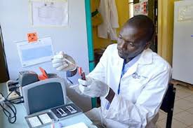

SUMMARY
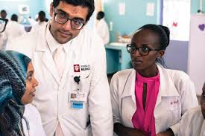

The relationships between the Indiana University (IU) School of Medicine – whose principal research and medical center is located on the Indiana University – Purdue University Indianapolis (IUPUI) campus in Indianapolis – and Kenyan partners in Eldoret dates back to 1989, when IU clinicians and researchers began to collaborate with medical professionals at Moi University’s new medical school. The mission of this new partnership was to develop leaders in health for the United States and Kenya, foster the values of the medical profession, and promote health and well-being in both countries. In early 2000, the recognition of the expanding HIV epidemic in sub-Saharan Africa, including in western Kenya, ignited the consolidation of these relationships into the Academic Model for the Prevention and Treatment of HIV/AIDS (AMPATH) – a vast collaborative project involving multiple institutions dedicated to improving the health of Kenyans, particularly through the prevention and treatment of HIV.¹ This three decade partnership, now known as the Academic Model Providing Access to Healthcare, has grown to include a consortium of more than a dozen other academic health centers throughout the world led by Indiana University. Collectively, these partners have established one of the world’s largest and most successful HIV care and control programs that has lessened the barriers to accessing antiretroviral therapy, improved the outcomes for people living with HIV, and made significant progress towards meeting the UN’s Sustainable Development Goal Agenda 2030.²

Today, AMPATH serves a population of over 8 million people in its western Kenya catchment area and there are currently 170,000 people living with HIV currently enrolled in care in over 800 care sites. Working with the Kenya Ministry of Health, the AMPATH partnership is focused on building a health system in the public sector that leads
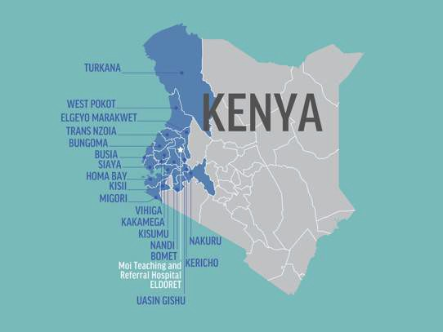with care in responding to the needs of the population including people with diseases such as malaria and tuberculosis as well as non-communicable diseases such as cancer, hypertension, and diabetes. This commitment to care provides the foundation for research to improve lives around the world and bidirectional educational opportunities to train future global health leaders from all members of the partnership.

This AMPATH partnership was built on the premise that individual and institutional good derives from the integrity of individual counterpart relationships. Now consisting of over 12 academic health centers around the world – led by Indiana University through the IU
Center for Global Health – the AMPATH Consortium continues to first emphasize quality healthcare, and then goes beyond to help people thrive through economic empowerment and self-sufficiency programs.

The AMPATH partnership continues to accentuate bilateral exchange, mutual benefit, and long-term commitment. It is departmentally-based and integrated across multiple disciplines and throughout all levels of participating institutions from student body to Department Heads and Deans. Funding for this collaboration comes from multiple
sources, including philanthropic support. The collaboration is an equitable partnership that creates opportunities for professional and personal development and scholarly achievements by medical faculty, staff, and students at partnership institutions. While demonstrating the power of medical education to improve the lives of vulnerable populations, the partnership fosters the tripartite academic mission of care, training, and research.

AMPATH is responsible for a restoration of hope for many Kenyans living with HIV through medical research, advanced on-site healthcare, fundraising, and patient support. Over the past decade, many IUPUI schools have joined the Moi University partnership and developed initiatives supporting AMPATH efforts, such as: The Social Science Research Network integrating the areas of sociology, anthropology, political science, traditional medicine, and geography with health; the Legal Aid Centre of Eldoret (LACE) addressing human rights issues faced by Kenyans with HIV and victims of sexual/domestic violence; and an engaged bioethics training partnership between Moi University and Indiana University.

HISTORY
What started as a small team coming together to grow a Kenyan medical school has developed into a global partnership between academic institutions in Kenya, North America, and around the world. Together, institutional and individual partners have pooled resources, knowledge, ideas, and passion to become one of Africa’s largest, most comprehensive and successful healthcare systems.

INDIANA UNIVERSITY-KENYA PARTNERSHIP

FORMED: 1989
PARTNERS: Indiana University School of Medicine and Moi University School of Medicine
PURPOSE: Started as an educational exchange between Indiana and Moi universities designed to train leaders in the medical field
OTHER INITIATIVES:
- Agricultural training programs
- Food assistance programs
- Skills training and small business loans
- Clothing, food, and tuition assistance to children orphaned by AIDS
The partnership between Indiana University (and in particular its IUPUI campus) and Moi University began in the late 1980s as a small-scale exchange program dedicated to the establishment of the Moi University School of Medicine. In 1988, Doctors Bob Einterz, Joe Mamlin, Charlie Kelley, and Dave Van Reken went on a three-week world tour looking for an international partner for the IU School of Medicine. What drew them to Eldoret, Kenya, was not only the need, but the vision of Moi University School of Medicine Dean, Dr. Haroun N.K. Arap Mengech, who was committed to build the new school’s curriculum around broad, community-based service. Moi University welcomed its first medical class of 40 medical students in 1990 – and Dr. Einterz became the first in a three-decade string of Indiana University faculty physicians to work alongside Kenyan colleagues, care for Kenyan patients, conduct health research, and teach American and Kenyan medical students.

The tripartite mission of the partnership provided opportunities for faculty members from both institutions in education, research, and clinical service. In but a few short years, the HIV/AIDS pandemic swept across western Kenya; in response, the partnership dramatically scaled up and in 2001 the Academic Model Providing Access to Healthcare (AMPATH) was born. The priority in AMPATH’s early years was in “putting out the fire” of HIV/AIDS – establishing and repurposing existing clinics to operate as a frontline resource, a classroom, and a laboratory.³

The ongoing – global – AMPATH medical collaboration has become the core component of the larger IUPUI–Moi University Strategic Partnership. Born out of the joint program of the medical schools, AMPATH now includes multiple schools and departments at both institutions, as well as a consortium of partners in the United States, Kenya, and Canada, including the schools of medicine at Brown University, University of Toronto, Johns Hopkins,

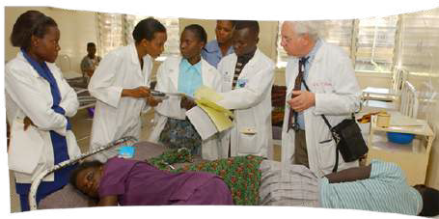Mount Sinai, University of Alberta, University of California San Francisco, Dell Medical School at The University of Texas at Austin, NYU Langone Health, as well as Purdue University, Duke University Hubert-Yeargan Center for Global Health and the Stanford Center for Innovation in Global Health.

Today, AMPATH is a primary care and chronic disease management partner of the Kenya Ministry of Health, and consortium partners are no longer narrowly targeting
disease control. Rather, they focus on broader public health issues and the social determinants of health impacting the Kenyan people.

THE AMPATH MODEL
The AMPATH model starts with healthcare. The academic health centers that make up AMPATH are uniquely situated to pursue a tri-partite mission of care, training, and research – the three components which are all essential for successfully addressing the short and long-term challenges of global health. While training and research are critically important to the program, AMPATH has always been determined to lead with care. Making a genuine effort to respond to the needs of an underserved population has laid the foundation for relevant and critical training and research. AMPATH was created in
response to the challenge of providing life- saving care in the face of the HIV pandemic, and today the Consortium continues to demonstrate that a community-based effort can combat the spread of disease and drastically impact global health.

Training (over 2,200 Kenyan and American medical trainees have participated in the program and thousands of Kenyan health care providers have been trained by AMPATH) and research (AMPATH researchers have published nearly 1,000 peer-reviewed publications and attracted over $187 million in cumulative funding for AMPATH-related research projects from NIH, CDC, and other sources) are also critical components of AMPATH’s efforts. This mission of care, research, and training is embraced by institutions like Brown University’s Alpert Medical School, Purdue University, Johns Hopkins University, University of Alberta, Duke University Hubert-Yeargan Center for Global Health, , Icahn School of Medicine at Mt. Sinai, University of California San Francisco, Stanford Center for Innovation in Global Health, NYU Langone Health, The University of Texas at Austin Dell Medical School, and University of Toronto Faculty of Medicine, who all have joined together with Indiana University as the AMPATH Consortium to partner with Moi Teaching and Referral Hospital and Moi University School of Medicine, working with Kenyan leaders to tackle the challenges of disease and poverty.

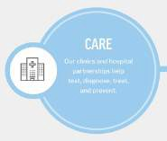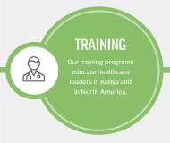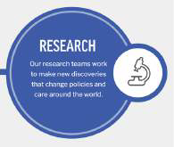

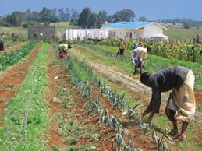
AMPATH’s programs are holistic and sustainable. In AMPATH’s definition of “healthcare,” the focus is on the patient, not the disease. If a patient is hungry, or without a job, or is the victim of discrimination or abuse, AMPATH will respond, a commitment that leads inexorably toward holistic care. Therefore, AMPATH not only treats people living with HIV and other health conditions at urban and rural clinic sites throughout western Kenya, they also have developed innovative programs to assure food and income security for thousands of individuals, including organizing more than 2,000 farmers into cooperatives that have successfully competed for contracts with the World Food Programme. AMPATH also provides school fees, nutrition, and other assistance to over 20,000 children left orphaned or
vulnerable due to HIV. Local leadership is the key to sustainability of any global health effort, so all of AMPATH’s programming is led and implemented by Kenyans. Sustainability is a core component of AMPATH at every level, as evidenced by the use of an advanced electronic medical record system to enable cost savings through task-shifting in clinical care (over 100 sites globally now host the AMPATH-originated Open Medical Records System, OpenMRS), overall program integration with the Kenyan government through an innovative partnership with the Ministry of Health, and their focus on developing income security for patients.

AMPATH PARTNERSHIP AND SDGs
While the commitment to care for people living with HIV remains a top priority, IU School of Medicine and AMPATH partners have expanded into care that includes chronic diseases such as cancer, diabetes, cardiovascular disease, mental health, maternal health, child health, and more. AMPATH currently serves a population of more than 8 million people in Kenya at over 800 clinical sites from village health centers and dispensaries to county hospitals to the Moi Teaching and Referral Hospital (MTRH).

AMPATH’s inclusive approach and comprehensive agenda has drawn faculty and students from a diverse range of schools. In so doing, AMPATH programs are able to address many of the broader dimensions of health care, such as safe water, nutrition, and family preservation, and also to become engaged in related fields such as legal aid, business development, and clinical pastoral education. Through addressing interconnected issues – such as poverty, hunger, and other factors – that fuel public health crises, and by providing enterprise training and other support, AMPATH has laid the foundation for its clients to live healthy and productive lives. The tireless efforts of IU School of Medicine, the AMPATH Research Network and their partner academic health centers around the world are working towards meeting the UN Sustainable Development Goals (SDGs) and the 2030 Agenda of global transformation through several aspects of the Kenya partnership.

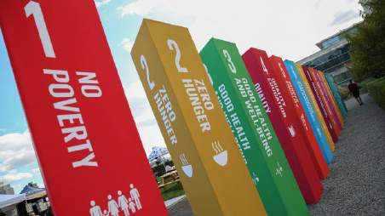
Health has a central position in the agenda through SDG 3 (Good Health and Well-Being) and is closely linked to over a dozen targets in other goals related to urban health, equal access to treatments, and non-communicable diseases, among others.⁴ The SDGs represent a unique opportunity to promote public health and well-being through an integrated approach to public policies and related efforts across different sectors. For example, better education for girls (SDG 4.1) in Kenya would improve maternal health (SDG 3.1); tackling child malnourishment (SDG 2.2) would have a great

impact on child health (SDG 3.2); and ensuring access to safe water (SDG 6.1) or substantially improving access to adequate sanitation (SDG 6.2 and decreasing pollution (SDG 11.6) will evidently have a direct impact on several SDG3 targets. Thus, the achievement of sustainable health goals will require coherent initiatives and approaches.

The multifaceted, transformative IU partnership in Kenya through the AMPATH Consortium has identified interrelated global development issues and is innovatively targeting these correlated SDGs through synergetic solutions. IUPUI, Indiana University, and AMPATH are working on projects that not only address SDG 3, but also 11 other SDGs that directly impact health – particularly SDG 4 (Quality Education), SDG 5 (Gender Equality), SDG 10 (Reduce Inequalities), SDG 9 (Industry, Innovation, and Infrastructure), SDG 2 (Zero Hunger), and 17 (Partnerships), in Kenya and North America.

SDG 3
SDG 3 aspires to ensure health and well-being for all, including a bold commitment to end the epidemics of HIV/AIDS, tuberculosis, malaria, and other communicable diseases by 2030. It also aims to achieve universal health coverage and provide access to safe and effective medicines and vaccines for all.

Below are ways in which the IU-Kenya Partnership and AMPATH are targeting specific aspects of SDG 3:

SDG 3.1 By 2030, reduce the global maternal mortality ratio to less than 70 per 100,000 live births.

In order to address concerns surrounding maternal mortality Indiana University (IU) School of Medicine and the IU Center for Global Health, in collaboration with University of Toronto’s Department of Obstetrics & Gynecology, support training for medical students and reproductive health registrars in obstetric care.⁵ At Moi University’s Teaching and Referral Hospital (MTRH) this initiative has systematically addressed maternal mortality through the development and implementation of an obstetric triage system, obstetric and post- abortion care protocols, and emergency medication kits for hemorrhage and hypertension.

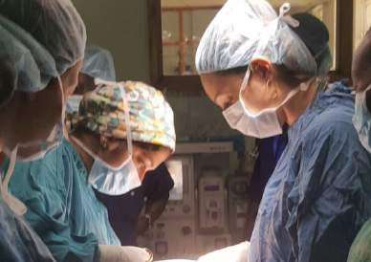
Additionally, this partnership has provided training in emergency obstetric and neonatal care to medical officers, nurses, and midwives at MTRH and outlying health care facilities. Through this collaboration, partners have developed a residency training program in obstetrics and gynecology to address the skilled provider gap and recruited the program’s first two Kenyan ob- gyns into the first Maternal Fetal Medicine (MFM) Fellowship program in East Africa.⁶ The purpose of this fellowship is to train Kenyan physicians in their home medical environment in the advanced care for high-risk pregnancies, including the use of ultrasonography and fetal-maternal monitoring systems.

The Chama Cha Mama Toto (Chamas) program is a community-based program geared towards addressing SDGs related to improving maternal and child health. In this program, women who are expecting around the same date typically meet two times per month with Community Health Volunteers (CHVs) for health and social lessons and participation microfinance activities is encouraged.⁷ Chamas groups – as well as the totality of the program – are low-cost, community-run, independently sustainable, and culturally-accepted. Currently, Chamas is inviting women in the antenatal, first- and second-year postpartum periods to participate in a three- year program. The main goals for this program are:

- Improving health services uptake (e.g. attendance of four or more ANC visits, facility delivery, visit of a CHV within 48 hours of birth, immunization uptake, or long-term family planning uptake)
- Achieving exclusive breastfeeding to six months
- Enrolling for National Hospital Insurance Fund (NHIF), a national insurance scheme
- Accessibility to a microfinance program focused on savings and loans
- Improving women's empowerment and peer support
- Reducing parental stress and harsh punishment within the home
- Reducing maternal and infant morbidity (e.g. low birth weight, preterm deliveries)
- Decreasing maternal, perinatal, neonatal, and infant mortality

In Indiana, the WeCare Program, is modeled on the community health worker model often used in Kenya. Funded by IU Health, Indiana Clinical and Translational Sciences Institute (CTSI), and the Indiana State Department of Health, WeCare trains community health workers in techniques to guide and support mothers, fathers, and caregivers toward behavior changes that decrease risk factors for infant mortality.⁸ These changes include reducing smoking, improving mental health, skipping fewer meals, and reducing substance abuse. The Central Indiana regional infant mortality rate decreased from 7.0 in 2018 to 6.4 in 2019.

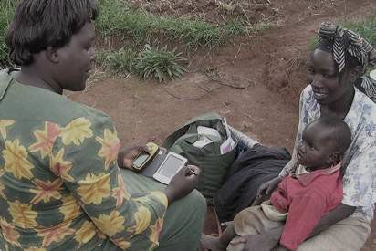
Fifteen percent of mothers in WeCare were self-reporting concerns about or use of illicit drugs which presented an opportunity to expand the use of community health workers in a new way. This extension, called Care Plus is now supporting women with substance use disorder and new mothers with babies suffering from neonatal abstinence syndrome (NAS) due to drug use during pregnancy.⁹ The program is one of 16 pilot projects selected to receive nearly
$1 million during the first phase of Indiana University’s “Responding to the Addictions Crisis” Grand Challenges initiative.¹⁰ The Richard M. Fairbanks Foundation provided an additional grant of more than $840,000 to focus on
mother-baby dyads who have experienced NAS.

SDG 3.2 By 2030, end preventable deaths of newborns and children under 5 years of age, with all countries aiming to reduce neonatal mortality to at least as low as 12 per 1,000 live births and under-5 mortality to at least as low as 25 per 1,000 live births.

Many of AMPATH’s programs aimed at the goal of reducing maternal mortality (SDG 3.1) – such as the Maternal Fetal Medicine (MFM) Fellowship and Chamas programs –positively impact infant and child mortality as well.
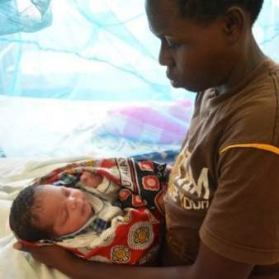
Additionally, the AMPATH Consortium has provided training in neonatal care to medical officers, nurses, and midwives throughout the western Kenya care network.¹¹

A specific example includes Dr. Sherri Bucher’s (Indiana University) work as an international mentor for Helping Babies Survive, as well as a country mentor for Kenya. Helping Babies Breath (HBB) teaches healthcare workers the initial steps of resuscitation to save babies who struggle to breathe at birth. HBB is part of Helping Babies Survive, an initiative of the American Academy of Pediatrics developed in collaboration with the World Health Organization.

Since the beginning of AMPATH, Indiana University has led efforts to prevent mother-to-child transmission (PMTCT) of HIV, an essential intervention to end preventable deaths of newborns and children
under 5 years of age. Through AMPATH’s clinic and home-based programs, mother-to-child transmission has decreased in AMPATH’s catchment area to less than three percent. AMPATH has been on the forefront of preventing mother-to-child transmission and ending preventable deaths of children and their mothers, including using more effective highly active antiretroviral therapy (HAART) (over single-regimen) therapies during pregnancy and integrating PMTCT services into routine maternal child health care in western Kenya.

Specialized newborn and pediatric care are also essential parts of the AMPATH partnership.¹² The Riley Mother Baby Hospital, built by AMPATH donors, and Shoe 4 Africa Children’s Hospital are part of the Moi University’s Teaching and Referral Hospital complex where a full-time pediatric team leader provides care to hospitalized children. Through these initiatives, North American trainees have the option to complete a rotation in pediatrics. Furthermore, in the past, Kenyan pediatric registrars have rotated at Indiana University for further neonatal and pediatric medical training. Currently, the first Pediatric Oncology Fellowship in Kenya has commenced and is being led by an Indiana University Pediatrics faculty.

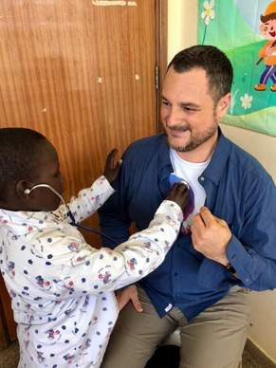
SDG 3.3 By 2030, end the epidemics of AIDS, tuberculosis, malaria and neglected tropical diseases and combat hepatitis, water-borne diseases and other communicable diseases.

The Indiana University (IU) School of Medicine has had a collaborative partnership with Moi University in Eldoret, Kenya, since 1990, and in the early 2000s – in response to the mounting global HIV epidemic – the institutions deepened their relationship by expanding their Academic Model for the Prevention and Treatment of HIV/AIDS (AMPATH). AMPATH was established as a joint initiative between Moi University School of Medicine, Moi Teaching and Referral Hospital (MTRH) and IU School of Medicine. The initial goal of AMPATH directly aligns with SDG 3.3 in that it has established an HIV care system to serve the needs of both urban and rural patients and to assess the barriers to and outcomes of antiretroviral therapy. The

first urban and rural HIV clinics were opened in November 2001 and by 2003 the partnership grew further through funding from the United States Agency for International Development (USAID) and the President’s Emergency Plan for AIDS Relief (PEPFAR). IU School of Medicine continues to support HIV care and treatment in western Kenya with technical assistance and advice with partners at MTRH and affiliated healthcare sites and is an active leader of the ongoing AMPATH Consortium.¹³

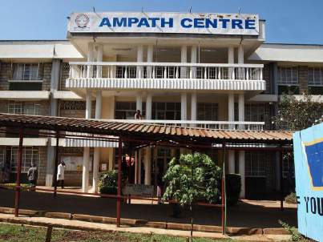
The AMPATH program currently supports HIV care and treatment in more than 800 clinics (i.e. testing sites, prevention of mother-to- child HIV transmission sites, and antiretroviral treatment clinics) in counties throughout western Kenya. Currently there are more than 170,000 patients who are actively receiving antiretroviral drugs. AMPATH operates a robust program to prevent mother-to-child transmission of HIV and has successfully reduced the rate of HIV transmission from mothers to their children to less than three percent.

SDG 3.4 By 2030, reduce by one third premature mortality from non-communicable diseases through prevention and treatment and promote mental health and well-being.
The Indiana University (IU) Center for Global Health works through AMPATH in western Kenya to prevent premature mortality from non-communicable diseases (NCDs) through direct patient care and supporting capacity building for care systems. Additionally, the Indiana University School of Medicine’s Division of Hematology/Oncology and Division of Pediatric Hematology and Oncology partners with their peer departments at Moi University (MU) and Moi University’s Teaching and Referral Hospital (MTRH) to train oncology providers and support staff, provide care to patients, establish oncology screening programs, and conduct oncologic research.¹⁴ Our largest breast and cervical cancer program has screened over 100,000 patients for cancer over the past three years and referred nearly 3 percent of patients for diagnosis and treatment of their cancer.¹⁵ Screenings, community cancer awareness, and health care worker trainings also occur in multiple myeloma, lung cancer, palliative care, and pediatric cancers. The AMPATH consortium has assisted MTRH’s oncology program’s growth from treating about 50 patients annually in 2005 to over 8000 in 2017. Additionally, the divisions have helped create a number of training programs including a Pediatric Hematology-Oncology Fellowship at MU in 2019 and an Adult Oncology Fellowship that is in the final stages of University review.¹⁶ Equipment for radiation therapy arrived at MTRH with the first patients treated in February 2021. Relatedly, the departments work to establish capacity to address effective, comprehensive care for cancer patients including expanding palliative care and pharmacy capacity.¹⁷
The IU School of Medicine, Center for Global Health, and Department of Medicine all partner with MTRH and the MU College of Health Sciences in western Kenya to expand training capacity, provide care, and improve the care provided for diabetes, hypertension, mental illnesses, and other NCDs. IU faculty teach medical students and registrars (i.e. the resident equivalent) at MU including on topics of NCDs. Additionally, IU faculty partner with MU and MTRH peers to manage funded projects to screen for diabetes, hypertension, and – providing 147,435 and 209,855 screenings, respectively, thus far in western Kenya. Simultaneously, the partnership has provided diabetes care to over 24,000 patients and treatment to more than 50,000 individuals with hypertension while training more than one thousand Kenyan colleagues in care management.¹⁸

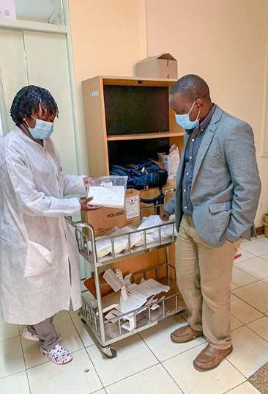
IU and MTRH faculty also manage a program to expand mental health care capacity in western Kenya. The IU Center for Global Health supports mental health research and care through donor and grant funds. The mental health program sensitizes communities and leaders on mental health. Specifically, this partnership is working with Kenyan counties to develop local mental health screening platforms, provide clinic-based mental health care to over 1100 patients, mentor 180 primary care providers on mental health care, and create a center to help inpatient mental health patients transition to a healthy, sustained lifestyle in the community. Collectively, these partnership initiatives focus on long-term capacity building, including the improvement of local training and health systems to provide sustainable improvements in non- communicable disease prevention and care systems over time.¹⁹
There is not enough community-based data to assess a baseline premature mortality or a current premature mortality in the AMPATH catchment area for any of these non-communicable diseases to compare for SDG 3.4. These
partnerships focus on long term capacity building including improving local training and health systems to provide sustainable improvements in the government care systems over time resulting in continued improvement in access and quality of care for non-communicable diseases.

SDG 3.5 Strengthen the prevention and treatment of substance abuse, including narcotic drug abuse and harmful use of alcohol.

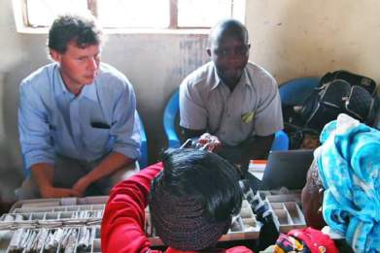
Indiana University (IU) School of Medicine partners with Moi Teaching and Referral Hospital (MTRH) and the Moi University (MU) College of Health Sciences in western Kenya to expand training capacity, provide care, conduct research, and improve capacity to address substance abuse in the
community through their broader mental health care and support program. This collaboration has conducted a number of studies to better understand substance abuse in western Kenya including analyses of specific populations such as prisoners, children living on the street, people living with HIV, and college students in order to explore effective interventions.²⁰

Additionally, achievements towards SDG 3.5 are being made through MTRH’s public inpatient substance abuse care program.
This initiative is one of few in western Kenya, and lessons learned from this program are being used to provide substance abuse training initiatives and mentorship to providers in Kenyan Ministry of Health facilities. This program is currently scaling up community-based substance abuse group interventions and now supports over 500 patients enrolled in 37 groups.²¹

SDG 3.6 By 2030, ensure universal access to sexual and reproductive health-care services, including for family planning, information and education, and the integration of reproductive health into national strategies and programs.

Currently there are 170,000 patients who are actively receiving antiretroviral drugs through AMPATH, of which over 83,000 are reproductive-age women. In order to achieve SDG 3.6, AMPATH has developed a robust program to integrate comprehensive sexual and reproductive healthcare (SRH) – including family planning provision – within its HIV care program to ensure access to all AMPATH clients. This program includes counseling about child spacing, pregnancy prevention and planning, STI prevention through the use of condoms, as well as provision of all reversible family planning methods – including long-acting reversible contraception (e.g. contraceptive implants and intrauterine contraceptive devices). Additionally, AMPATH has partnered with the Kenyan Ministry of Health (MOH) to improve family planning services through supply chain and commodity management, community engagement, and education and healthcare worker training. Most of the MOH care clinics which AMPATH supports provide integrated family planning services.

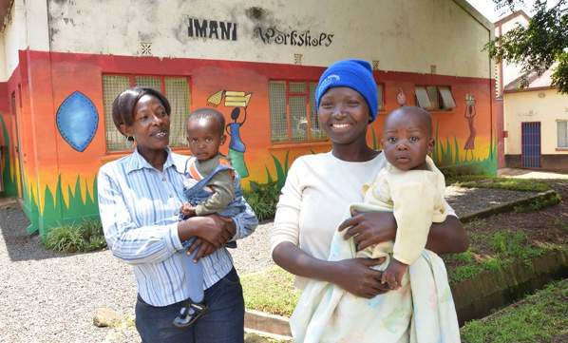
Indiana University (IU) School of Medicine and the IU Center for Global Health – in collaboration with the University of Toronto (UT) Department of Obstetrics & Gynecology – also support teaching, research, and care through grant and donor funding. This includes expanding access to SRH through the following:
integration of family planning services into chronic disease management; community-based provision of urine pregnancy testing to improve linkages to SRH and early pregnancy care; understanding issues related to SRH in women living with HIV; peer-led adolescent sexual and reproductive health education; and support groups in neighboring areas.

The Departments of Obstetrics & Gynecology at IU School of Medicine and UT support training of medical students and reproductive health registrars at Moi University’s Teaching and Referral Hospital (MTRH) in order to prevent and manage SRH-related conditions. Additionally, the initiative has developed the first Fellowship in Gynecologic Oncology in East Africa, providing for the advanced training of Kenyan physicians and oncology care for women with cervical and other gynecologic cancers at MTRH. This program also facilitated – in partnership with the Ministry of Health – widespread access to cervical cancer screening throughout AMPATH-assisted facilities in western Kenya.²²

SDG 3.7 Achieve universal health coverage, including financial risk protection, access to quality essential health-care services and access to safe, effective, quality and affordable essential medicines and vaccines for all.

The Government of Kenya has committed to a Big Four Action Plan that includes achieving 100 percent Universal Health Coverage by scaling the National Hospital Insurance Fund (NHIF) uptake by the year 2022. AMPATH – led by Indiana University, Moi University, and the Moi Teaching and Referral Hospital – is uniquely positioned to demonstrate how to achieve this goal and can serve as a model for this national commitment.²³

Over the past five years – with support from the AbbVie Foundation – AMPATH has capitalized on its strong foundation in HIV, maternal, newborn and child health and non-communicable disease care to seed a novel

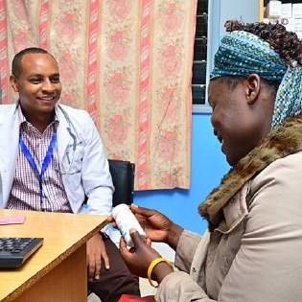
pathway to an integrated and quality health care delivery system. This model prioritizes health and wealth creation by leveraging a national insurance product and scaling income generating activities. Through partnerships, AMPATH has established a county care network capable of providing the comprehensive benefit package delineated by the NHIF. Combined, Kenya and AMPATH’s commitment to universal health coverage can establish sustainable models for partnering Ministries of Health (MOH) that are based on the integrated care initiatives built from AMPATH’s population health principles and practices. AMPATH’s model of universal health coverage includes:

- Empowering the community’s economic strengths by increasing the number and impact of community groups that support income
generation, local savings and loans (table banking), financial literacy, food production, nutrition, and healthcare. Currently, more than 30,000 Kenyans are mobilized into community groups supporting income generation and positive health behaviors.
- Creating a seamless care system that provides primary and specialty care for families that begins in the community and ends at the referral hospital.
- Providing universal health insurance by collaborating with Kenya’s NHIF to ensure that the health care delivery system is financially accessible to all people.

Additionally, AMPATH has initiated a revolving fund pharmacy (RFP) model to improve access to essential medicines in rural health facilities. The RFP locations provide back-up supplies of crucial medications in the event that pharmacies in government health facilities are short of supplies and medicines.¹ Patients purchase the medicines from the RFPs when those medicines are not available in the government pharmacy, and the money collected is then used to restock the pharmacy, thereby ensuring sustainable and continuous availability of essential medications and eliminating life-threatening shortages of medicines. The prices of medications at the RFPs are slightly higher than the government pharmaceutical facilities, making it the second place a patient might want to try – but medication costs remain much lower than in private pharmacies.²⁴

SDG 3.8 By 2030, substantially reduce the number of deaths and illnesses from hazardous chemicals and air, water and soil pollution and contamination.

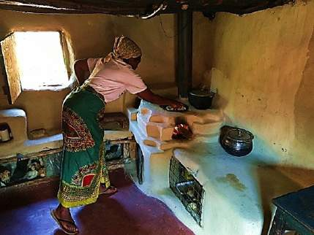
Many traditional Kenyan communities cook using biomass fuels like wood and agricultural wastes in inadequately ventilated kitchens. The women and children who spend more time in these kitchens suffer the most from the effects of indoor air pollution, which is linked to many respiratory illnesses and deaths.

In order to address this issue – and work towards SDG 3.8 – Nandi-improved kitchens were designed jointly with women from the Nandi community and AMPATH Consortium member Purdue University through their Global Air Quality Trekkers (GAQT) engineering team. The team has been able to compare the pollution rates of the traditional kitchens and the Nandi-

1 Purdue University’s College of Pharmacy is a partner for the development and implementation of the RFP model.

modified kitchens using low-cost detectors installed in both kitchens. The improved kitchens are designed to improve ventilation mainly through increasing window and door sizes, creating a vent, including a roof wall gap, and introducing a chimney to the traditional stove to ensure there is maximum air flow for better ventilation. The improvements in the kitchen and stove designs have led to an 80 to 90 percent reduction in the concentration and exposure to wood smoke and carbon monoxide while cooking.²⁵

With these kitchens, women can now nurture their families without exposing themselves to the risks and effects of indoor air pollution. The problem of indoor air pollution is widespread in rural homes among low- and middle- income counties and there is a huge need to address this issue through community- led innovations similar to the Nandi Kitchens.

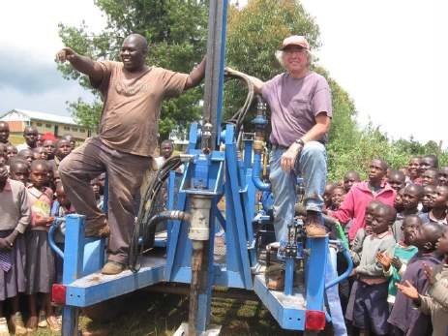
Maji Safi International LLC (MSI) was started in 2015 as an outgrowth of AMPATH’s safe water program in collaboration with the AMPATH Consortium, through Indiana University and Purdue University partnership. Its mandate was to continue the safe water programs as a
sustainable business. Looking forward, the future of Maji Safi will contain five basic elements: distribution and sale of ceramic filters at the household level; community and school water systems; drilling to install funded or commercial boreholes; consulting and contracting for projects; and community trainings and outreach. To date, MSI has sold over 5,000 household filter units (ceramic filters) and installed 11 school water treatment systems in collaboration with Purdue research groups.

MSI is also collaborating with researchers at Purdue to customize the school (or community) water systems for western Kenya and develop an affordable water testing and
impact reporting kit. The customization of water systems will reduce labor needs and ensure consistent water quality. The phone-based water quality kit will enable daily testing and reporting (via text massage) to Maji Safi. The daily monitoring will include both water quality and volume of water treated.²⁶

SDG 3.B Support the research and development of vaccines and medicines for the communicable and non- communicable diseases that primarily affect developing countries, provide access to affordable essential medicines and vaccines, in accordance with the Doha Declaration on the TRIPS Agreement and Public Health, which affirms the right of developing countries to use to the full the provisions in the Agreement on Trade Related Aspects of Intellectual Property Rights regarding flexibilities to protect public health, and, in particular, provide access to medicines for all.

One example of the AMPATH partnership’s contribution to achieving SDG 3.B is the Revolving Fund Pharmacy (RFP).

A crucial, frequently overlooked element of a healthcare system is a reliable supply chain which ensures consistent access to vital commodities – particularly medications. Failure in this aspect of the healthcare system can obviate many of the gains made in the preceding steps as patients will be unable to carry out the prescribed recommendations. In order to address these deficiencies, AMPATH has been able to work with its county-based partners to implement RFPs across western Kenya. Within this model, a fully audited and separate pharmacy is established within existing Ministry of Health facilities, which ensures all revenues are re-invested into purchasing replacement stocks for the RFP. Application of this model has increased the availability of essential medicines from

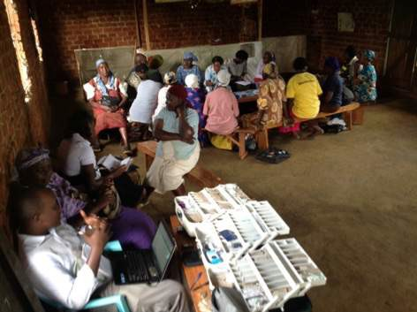
less than 40 percent to more than 90 percent, filled over five million prescriptions, and sustained 85 distinct pharmacies across the vast catchment area.

In addition to supplying medications, these pharmacies have also been able to improve availability of lab reagents by stocking frequently stocked strips for glucose and other point- of-care tests. The unprecedented success of this model has been documented in numerous journal articles and papers – and has received numerous grants and awards.²⁷

SDG 3.C Substantially increase health financing and the recruitment, development, training and retention of the health workforce in developing countries, especially in least developed countries and small island developing States.
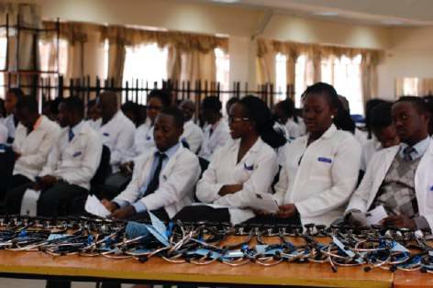
Over the years, more than 1,000 citizen health volunteers have been trained by AMPATH to provide care and education throughout their own communities in western Kenya, which has been integral to the success of AMPATH’s HIV care program and has expanded to address related initiatives for economic empowerment, chronic disease, and maternal and child health. One example which is aiding in reaching SDG 3.C is the Chamas Cha Mama Toto (Chamas) program. Chamas has trained nearly 600 community health volunteers to lead biweekly prenatal and early child group care and education sessions for more
than 5,000 women in four counties in western Kenya. Additionally, the AMPATH Population Health Program supports the continued mentorship of clinical officers at outlying sites within the Moi Teaching and Referral Hospital catchment area through advanced chronic disease care on- the-job training. Other activities include utilizing the ECHO platform that supports telemedicine education and training, launching a diploma in chronic disease management for clinical officers (i.e. physician extenders), and establishing a quality improvement training and mentoring program for healthcare workers in Busia County.
Indiana University faculty member Dr. Sherri Bucher serves as an international mentor for Helping Babies Survive, an initiative that teaches healthcare workers the initial steps of resuscitation to save babies who struggle to breathe at birth. Helping Babies Breathe (HBB) is part of Helping Babies Survive, an initiative of the American Academy of Pediatrics developed in collaboration with the World Health Organization.
IU School of Medicine and University of Toronto have collaborated, started, and supported the following training programs at Moi Teaching and Referral Hospital (MTRH) and Moi University, including a registrar/post-graduate training program in obstetrics and gynecology and fellowships in maternal fetal medicine and gynecological oncology (both fellowships are the first of their kind in East Africa). Additional training efforts include ALARM- international and other emergency obstetrics courses for obstetrical care providers. Education-focused workshops in minimally invasive surgery commenced, but the program has stalled because of the COVID-19 pandemic.

AMPATH partners collaborate on creating opportunities for training and skill enhancement for health care professionals at all levels of the care system. Noteworthy training opportunities include:

- 18-month training curriculum with MTRH for training physician extenders in oncology to be able to assist and do screening, early diagnostics, management of cancer patients in multidisciplinary teams, palliative care, and appropriate referrals and survivorship care.
- An established MOU between the University of New Mexico’s ECHO Institute and MTRH and MU to allow use of the ECHO platform for video-case conferencing and guided practice sessions for providers and trainings located throughout Western Kenya and beyond.
- Lymphoma preceptorships that have trained over 1000 health care professionals.
- Lung cancer trainings that have trained over 300 health care professionals.
- Chemotherapy administration and Chemosafe trainings trained over 800 health care professionals.
- Multiple myeloma trainings that over 400 health care professionals have completed.
- Clinical Investigator Training Enhancement (CITE-Kenya) Program culminates in an MS or graduate certificate in clinical research.

More of AMPATH’s health education advancements are listed under SDG 4 (Quality Education). These include the development of a second medical school in Kenya, bilateral exchange for medical students and medical residents, and fellowship development in cardiology, pediatric oncology, and the reproductive health fellowships described above.²⁸

SDG 3.D Strengthen the capacity of all countries, in particular developing countries, for early warning, risk reduction and management of national and global health risks.

Antimicrobial resistance (AMR) is an urgent threat to global public health. In Kenya, while reliable data on antimicrobial resistance is lacking, a number of health system factors likely contribute to ongoing development of resistant organisms.²⁹

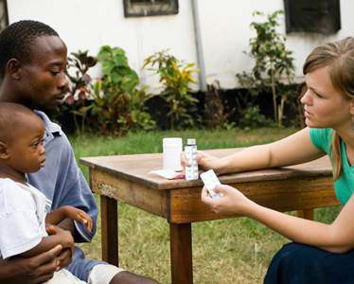
The core elements of an effective institutional antibiotic stewardship program include institutional commitment and leadership; availability of expertise on infection management; ongoing education and training; action plans aimed at appropriate antimicrobial use; and regular monitoring, surveillance, and reporting. Thus, the AMPATH Consortium, in support of the Moi Teaching and Referral Hospital (MTRH), and with funding from Pfizer Foundation, is being used to enhance clinical care protocols and microbiological laboratory capacity in order to generate reliable microbiological data that will then be used to inform local clinical practice, educational activities for medical trainees and providers, and hospital and national policymakers. AMPATH is well-positioned to evaluate the impact of implementation of novel diagnostics and
antibiotic stewardship efforts on clinical outcomes and on antimicrobial use, making the Consortium central to achieving SDG 3.D. The project’s scope also includes lower-level facilities and their surrounding communities, where AMPATH aims to expand work with county governments to develop a better understanding of factors driving inappropriate antibiotic use in the inpatient and outpatient setting, increase availability of appropriate diagnostics, support training for laboratory technicians, and encourage a health systems approach to ensuring quality care for infectious diseases.

In 2020, AMPATH’s sponsored AMR project made significant progress despite the unexpected challenges presented by the COVID-19 pandemic. The initiative saw completion of the new MTRH microbiology laboratory and was able to enhance its capabilities with the purchase and placement of equipment supporting blood cultures and rapid, molecular diagnostics. Additionally, computer software was installed to track bacterial identification and antibiotic resistance data from the existing lab systems. A small staff was hired to assist MTRH personnel – such as clinicians,
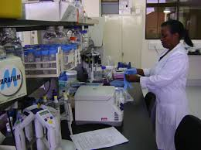
nurses, pharmacists, infection control specialists, and laboratory specialists – already in positions to promote and assure practices consistent with decreasing AMR. Utilization of existing MTRH staff ensures that the adoption of good infection control practices is widespread throughout the hospital and facilitate sustainability of these practices. MTRH’s Drugs and Therapeutics Committee and Antimicrobial Stewardship Committee are addressing issues related to antimicrobial stewardship, infection control, infection detection practices and laboratory practices. Furthermore, AMR awareness posters and an AMR Awareness Week were held with education and activities targeted at hospital staff, patients, and community stakeholders.

SDG 1 and SDG 2
SDG 1 aims to eliminate extreme poverty throughout the world, while SDG 2 targets the end of hunger and the achievement of food security, improved nutrition, and sustainable agriculture by 2030. The aim of the latter is to ensure that everyone has enough good-quality food to lead a healthy life.

The first pillar of AMPATH’s population health model focuses on economic empowerment, centrally positioning the partnership to attain sustainable solutions to poverty and hunger. For example, AMPATH’s microfinance groups provide a path to health and wealth for thousands of Kenyans working in the informal sector. Through these initiatives, savings and loan groups supported by AMPATH have demonstrated the role of wealth in healthcare access and affordability. Additionally, these lending and savings groups have provided an excellent platform to extend health services, such as early screening for chronic diseases and the promotion of health insurance.

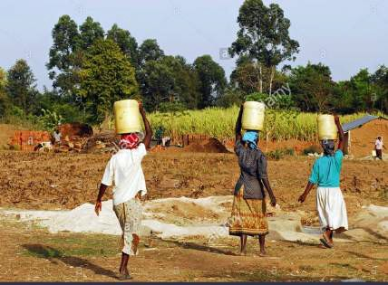
Working towards solutions for food security, AMPATH has partnered with Corteva to work with farmers throughout western Kenya to learn the best, most efficient farming techniques, understand how to manage their resources, and understand how to commercialize their products. All of this leads to more successful farmers, who in turn have more resources to spend on healthcare and make their health a priority.

During the COVID-19 pandemic, AMPATH microfinance and farmers groups have adapted and implemented new strategies to stay together despite restrictions on gatherings. AMPATH is also providing philanthropic funds directly to members of some
microfinance groups to help offset the loss of income and economic strain of the pandemic.³⁰

SDG 4
SDG 4 aims to ensure inclusive and equitable quality education and promote lifelong learning opportunities for all by 2030. The main target of this goal is to ensure that all girls and boys complete free, equitable and quality primary and secondary education leading to relevant and effective learning outcomes. A provision of at least one year of free and compulsory quality pre-primary education is encouraged, to be delivered by well-trained educators, as well as that of early childhood development and care.

Through the AMPATH Consortium, Indiana University is working to achieve SDG 4 by supporting the education of Kenyan medical students, medical post-graduates, and the specialty training of fellows through collaboration with Moi University’s College of Health Sciences and the Moi University Teaching and Referral Hospital.

IU School of Medicine supports year-round faculty members in Kenya in medicine (30+ years), pediatrics (15+ years), surgery (11+ years) and Ob/Gyn (10+ years in collaboration with University of Toronto). Over the course of the partnership, other year-round positions have included public health, oncology, and cardiology. The IU School of Medicine and IU Center for Global Health also support the AMPATH Consortium executive field director and other leadership positions. Other faculty members travel to Kenya for short-term presence in most medicine and surgical sub-specialties, such as: anesthesia, psychiatry, neurology, pathology, ENT, ophthalmology, emergency medicine, basic sciences, bio-statistics, public health, nursing, and dentistry. Faculty members serve as visiting faculty at MU School of Medicine and teach both Kenyan and North American trainees in the clinical setting. Additionally, more than 60 Moi faculty members have been hosted by the Consortium in North America for short or long-term visits and clinical training.

Through charitable donations, AMPATH has also delivered over 500 full-tuition scholarships for Kenyan medical students with financial need to attend Moi University School of Medicine. The total cost for all scholarships awarded to date is more than $250,000.

One of the foundations of the original partnership between IU and Moi University was the bi-directional exchange of medical students and other trainees. Through this program, each year, approximately 20 students from Moi University are sponsored to complete an elective rotation at one of twelve North American AMPATH medical training institutions. Since 1995, more than 340 Kenyan medical students, 14 dental students, and over 50 registrars have participated in this exchange. The AMPATH educational exchange program has also included trainees from other disciplines, including pharmacy, nursing, dentistry, public health, engineering, agriculture, law, business, and journalism.

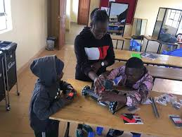
The AMPATH Consortium has also supported specialty clinical training at Moi University, including the establishment of a number of residency programs and training fellowships in the fields of pediatric oncology, cardiology, gynecologic oncology, and maternal fetal medicine. Through training grants from the National Institute of Health and other sponsors led by AMPATH Consortium members, Moi University and Moi Teaching and Referral faculty, students, and staff have also taken part in training programs in medical informatics, biostatistics, research administration and management, and research ethics.³¹

Individuals throughout the AMPATH Consortium support multiple educational activities for students in Kenya through involvement
with the Tumaini Innovation Center – an alternative school in Eldoret focused on quality education for current and former street youth. Since 2015, more than 40 former street youth have undergone the engineering training that complements their primary and vocational education at the center. This localized engineering program model uses novel pedagogies to build 21st Century skills to prepare the youth for the workforce and sustainable livelihood. The program also builds teachers' capacity using Community of Practice (CoP) and Participatory Research approaches, thereby empowering local teachers as champions of the program. There also exists a study abroad program whereby Purdue engineering students can travel to Tumaini to participate as global learners.³²

SDG 5
SDG 5 aims to achieve gender equality and empower all women and girls. Gender equality is not only a fundamental human right, but a necessary foundation for a peaceful, prosperous, and sustainable world. In order to attain this goal, all forms of discrimination against women and girls everywhere must end. Additionally, all forms of violence against all women and girls in the public and private spheres – including trafficking, sexual, and other types of exploitation – must be eliminated. Gender equality by 2030 requires urgent action to eliminate the many root causes of discrimination that still curtail women’s rights, for example laws that structurally imbed gender discrimination must change and new legislation adopted in order to proactively advance equality.

IU’s partnership in Kenya through the AMPATH Consortium is leading a number of efforts to achieve gender equality by 2030. For instance, the registrar programs at Moi University – which were initiated with support from the AMPATH partnership – include in their terms of reference and recruitment policy that attention be paid to gender equality in recruiting efforts. As such, gender parity is required for every incoming cohort, and more than half of registrars are female. AMPATH also supported the development of a sexual and gender-based violence (SGBV) care clinic and legal support clinic at Moi Teaching and Referral Hospital, both of which provide advocacy and support for women and girls who survive violence.

Gender equity is an important focus of efforts in reproductive health through AMPATH, and principles of reproductive justice, human rights, and feminism inform care priorities, project proposals, and the kind of funding sought. Additionally, intersections of education, health, and financial empowerment are key drivers in existing and past gender-related programs. These include:

- Chama cha mama toto – Community Health Volunteer-led peer support groups that combine health education and microfinance for pregnant and parenting women.
- The adaptation of the Chama cha mama toto program for pregnant adolescents is engaging adolescent women in the re-design.
- Human-centered design is used to engage adolescents in designing pregnancy and sexual and reproductive health care and education programs.

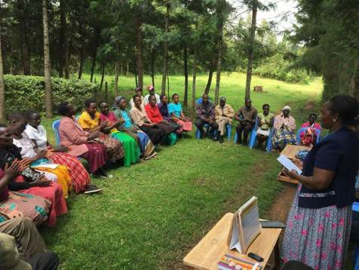
Human-centered design involves engaging the end-user in defining a problem and designing the solution and has been effectively adapted into healthcare settings – by engaging the end user they are more likely to use the solution that is rolled out. This approach has further led to the design and launch of an empathy-driven health care provider training program in Adolescent Sexual and Reproductive Health (ASRH) that involves adolescents as experts in their own care; a peer mentor training program for adolescents in ASRH; and, because of these efforts, the establishment of an adolescent antenatal clinic and program. AMPATH continues to work with county governments to strategize and develop programming to address ASRH and pregnancy needs, particularly in environments with strong social stigmas.

AMPATH launched the Rafiki Centre – a Centre of Excellence in Adolescent Health – in 2015, to provide care for HIV, mental health, and sexual reproductive health (SRH). This is the only such center in western Kenya and offers post- exposure prophylaxis, pre-exposure prophylaxis, sexually-transmitted infection testing, contraceptive services, and pregnancy options counseling. Further, in accordance with the Kenya policy on the provision of youth friendly services, the site offers peer-led health education and social activities. Additionally, a robust street outreach program developed with participatory design techniques with and for street-connected youth has been established and includes pairing HIV testing and therapy with the provision of free hot meals and peer support groups for street- connect youth that combine SRH education and microfinance opportunities. These efforts have been shown to reduce sexual and gender-based violence and increase condom use, contraceptive uptake, and STI testing.

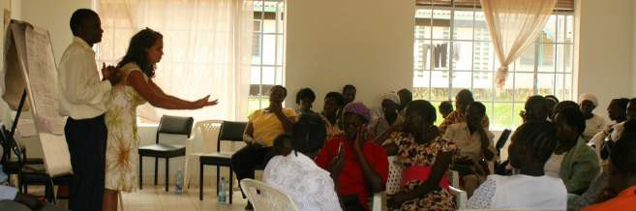
Furthermore, 80 percent of participants in AMPATH’s community groups are women and nearly 80 percent of AMPATH’s clients are also women. Therefore, gender equality and female empowerment are central to AMPATH’s work. In 2009, AMPATH initiated the Group Integrated Savings for Health
Empowerment (GISHE) loan and savings initiative to address the capitalization challenge that clients face. There are now 2,456 GISHE groups in western Kenya, with a membership of 50,361 – 81.2 percent of members being women. This initiative has provided more than 30,000 women access to financial services and livelihood interventions. In addition, AMPATH has initiated an intervention that utilizes these community groups as healthcare delivery vehicles for screening, drug delivery, and basic clinic follow ups. This model has availed structured opportunities for women to access livelihoods and financial services and it is an infrastructure that has started to avail health access to more women in the safety of their social support structures.

Again, the Chamas program is another example of AMPATH’s group structure that empowers women. Similarly, the Legal Aid Centre-Eldoret (LACE) was established to provide legal support for AMPATH clients, mostly women (and children), who faced sexual abuse, domestic violence, and disinheritance among other forms of abuse. This centre has been an important platform to strengthening paralegal services and support targeting women and establishing mechanisms to mitigate against continued abuse.³³

SDG 6
SDG 6 aims to ensure the availability and sustainable management of water and sanitation for all by 2030. Most notably, this goal targets to achieve universal and equitable access to safe and affordable drinking water for all. The goal also emphasizes the efficient use of water and the protection of freshwater supplies.

Through clean water access and hand-washing initiatives, the AMPATH partnership is contributing to achieve SDG 6.

Notably, due to COVID-19 restrictions on social gatherings, AMPATH’s Group Integrated Savings for Health Empowerment (GISHE) microfinance group meetings were halted earlier this year. This has threatened the gains made in group formation and mentorship and has also weakened the financial ability of many households

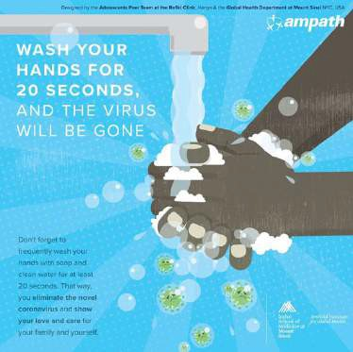
dependent on the groups for business capital. The economic toll of COVID-19 has been immense and the ability to resume microfinance group activities to allow families to build wealth is an urgent priority. However, through the generosity of AMPATH supporters, in September 2020 AMPATH project officers distributed over 2,000 hand washing containers and soap to group leaders and local chiefs so group members can continue to save and provide for their families’ health in a safe environment.³⁴

The Maji Safi initiative (See SDG 3.8 for more) evolved from AMPATH’s clean water initiatives and has a diverse set of aspirations for implementing clean water solutions at the household, school and community level including the sale of water filters and installation of school water systems.

Recently, youth at the Rafiki Centre for Excellence in Adolescent Health inspired, envisioned, and conceived the ideas for the above seen COVID-19 graphic, later created by AMPATH partners at Arnhold Institute for Global Health at Icahn School of Medicine at Mount Sinai.

SDG 8
SDG 8 is about decent work and economic growth. This goal aims to promote sustained, inclusive, and sustainable economic growth, full and productive and decent work. This SDG encourages higher, sustained levels of productivity and technological innovation – encouraging entrepreneurship and job creation around the globe. The main target is to achieve full and productive employment, and decent work, for all women and men by 2030.

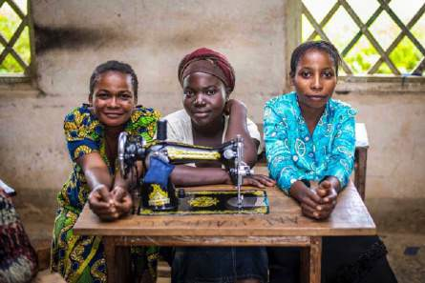
Created by AMPATH partners in 2005, the Imani Workshop targeted SDG 8 through its aim of providing sustainable income opportunities to HIV-positive women in western
Kenya. The workshop produced handicrafts (e.g. sewn products, paper arts, ceramics, etc.) for local and international sale under decent and fair working conditions. The operation grew to employ over 100 people, including individuals with disabilities and those who receive medical treatment and support through AMPATH. Recently, the Imani Workshop evolved into an operation independent from the AMPATH Partnership called Creation Hive. This independent initiative operates with the same mission and goal to inspire, prepare, and employ individuals and families affected by life changing diseases. The Workshop remains driven to assist undeserved communities succeed in a local and global economy.

SDG 9
SDG 9 focuses on industry innovation and infrastructure and is aimed at building resilient infrastructure while promoting sustainable industrialization and fostering innovation. Inclusive and sustainable industrialization, together with innovation and infrastructure, can unleash dynamic and competitive economic forces that generate employment and income. These approaches can play a key role in introducing and promoting new technologies, facilitating international trade, and enabling the efficient use of resources. Expanding manufacturing and scaling up investments in scientific research and innovation are at the heart of this goal for developing nations and must be achieved to meet the 2030 target.

Targeting SDG 9, the Indiana University Center for Global Health (IUCGH) as the lead of AMPATH’s North American Consortium is focused on building workforce, organizational, and physical infrastructure for the health system in western Kenya. AMPATH is intentionally not a legal entity in Kenya to ensure Moi University (MU) and Moi Teaching and Referral Hospital (MTRH) lead all projects – inspiring and supporting local agency, capacity, and ownership of innovation and development. A primary example of this commitment to developing capacity and leadership in
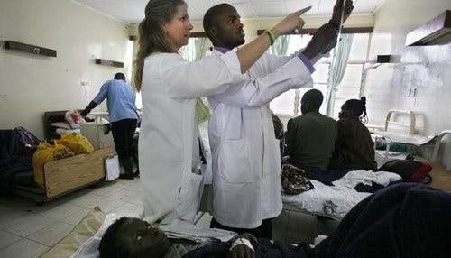
Kenya can be demonstrated through AMPATH’s history of HIV funding from USAID. Indiana University (IU) served as the prime institution for the first five- year PEPFAR grant to scale and deliver HIV care in western Kenya. During this life of this grant, IU leadership placed emphasis on developing Kenyan leadership and financial management capacity so that in 2012 USAID awarded the PEPFAR renewal directly to MTRH – making it the primary organization and the recipient of, at the time, the largest USAID PEPFAR grant awarded to a local African institution.

AMPATH’s commitment to the development of Kenyan organizational infrastructure has helped MU and MTRH in developing management infrastructure for health systems, accounting and human resources capacity through the Research and Sponsored Projects Office, ethics approval through the Moi University Institutional Research Ethics Committee, monitoring and evaluation infrastructure for care programs, and the creation of new care departments in areas such as oncology and cardiology. Workforce infrastructure development has included developing training programs, as well as mentorship and support for each of the administrative areas listed above.² Physical infrastructure development has included Kenya’s second public-sector radiation oncology machine, phototherapy equipment, laboratory equipment – as well as philanthropic support to build the following buildings at MTRH:

- Chandaria Cancer and Chronic Diseases Center ($5.5 million)
- Cardiac Care Unit, including its equipment ($300,000)
- Riley Mother and Baby Hospital ($2 million)

2 See SDG 4.

- AMPATH Centre ($2 million)
- Mosoriot AMPATH HIV Clinic ($50,000)
- Majaliwa Operating Theatres ($200,000)
- Mental Health Transitional Home ($220,000, under construction)
- Neurodevelopmental Care Center ($200,000, in planning phase)
- Burn Centre ($1.5 million, in planning phase)

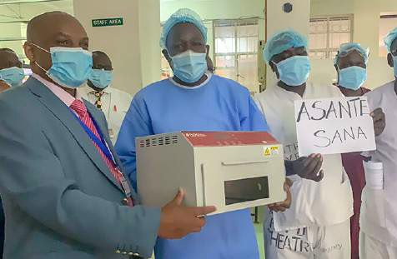
Additionally, it should be noted that the AMPATH Partnership has fostered innovation as shown through nearly 1000 academic publications with Kenyan authors, offering research improving the quality and delivery of health care in western Kenya and globally. The collaboration has also led to the creation of the electronic AMPATH Medical Record System – now in use in over 70 countries as OpenMRS.³⁵

SDG 10
SDG 10 targets the reduction of inequality within and among countries around the world. The goal consists of
10 targets, including the main aim of progressively achieving and sustaining income growth of the bottom 40 percent of the population at a rate higher than the national average. In order to achieve this main intention of this goal, social, economic, and political inclusion of all – irrespective of age, sex, disability, race, ethnicity, origin, religion, or economic status – must be successfully promoted.

The Indiana University Center for Global Health (IUCGH) and its AMPATH partners operate within a mission founded on the idea of equitability – pursuing a vision of ensuring quality healthcare for all. AMPATH partners collaborate to improve the health of millions of people in western Kenya, while training the next generation of medical leaders and creating a research infrastructure to improve health in Kenya and around the world.

North American faculty members in Kenya support the care and teaching missions by educating students and trainees in both classrooms and clinical settings and serving as research mentors. A full-time faculty presence in medicine and other specialties has been a key component of the partnership since its founding in 1990. Additionally, AMPATH’s bidirectional commitment to training and education has provided opportunities for hundreds of Kenyan medical students and registrars to complete clinical rotations in North America. This commitment has also led to the development of ground-breaking post-doctoral opportunities including fellowships in gynecology oncology, maternal fetal medicine, cardiology, pediatric oncology, and other needed subspecialty areas.

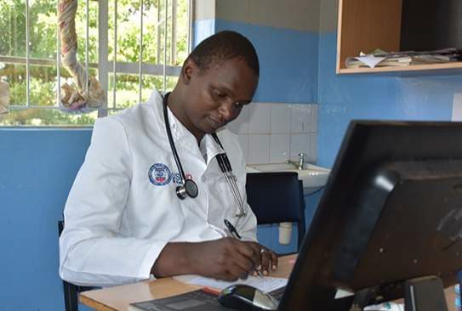
The partnership has provided institutional and systems support including the building of facilities for HIV care, cancer and chronic diseases, operation theaters for surgery, and obstetrics and newborn care. With more than
$187 million in total cumulative research funding from the NIH, CDC, Bill and Melinda Gates Foundation, USAID and others, AMPATH supports a robust research program and infrastructure with more than 70 active research projects. This infrastructure includes an ISO-accredited research laboratory and biorepository; a research ready medical records system with a cohort of more than 220,000 patients in western Kenya; a clinical trials unit; and an Institutional Research Ethics Committee (IREC). AMPATH’s
collaborative research efforts have produced nearly 1000 publications in peer-reviewed journals, and, to date, more than 200 trained researchers and support staff have led efforts related to HIV, malaria, cancer, diabetes, and many other health challenges.³⁶

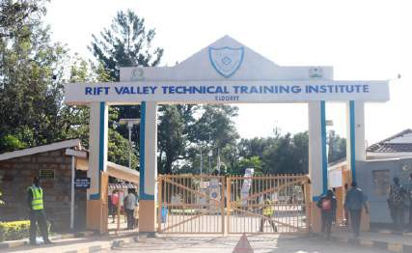
One specific research focus has been the development of a system that incubates initiatives focused on reciprocal innovation. In global health research, reciprocal innovation is a collaborative process to exchange lessons learned and co-develop technology and health innovations with mutual benefit to health partners in both low- and middle- income countries (LMIC) and the United States. In cooperation with the Indiana Clinical and Translational Sciences Institute (CTSI), IUCGH awards both planning and demonstration grants that foster innovative global health research partnerships and projects to improve the health and well-
being of Indiana citizens and people in resource-limited communities around the world. The adaptation of the Kenyan community health worker model to improve infant mortality in the WeCare Program is an example of a successful reciprocal innovation.³⁷

The hope of AMPATH is that one day all people – no matter where they live and what socioeconomic challenges they face – will have access to the healthcare and other resources they need to thrive in life.

SDG 16
SDG 16 focuses on achieving peace, justice, and strong governance institutions around the world. Specifically, the goal promotes peaceful and inclusive societies for sustainable development, provide access to justice for all and build effective, accountable and inclusive institutions at all levels. A key target in achieving this goal is the development of effective, accountable, and transparent institutions at all levels – empowering inclusive participation within representative institutions under an equitable rule of law.

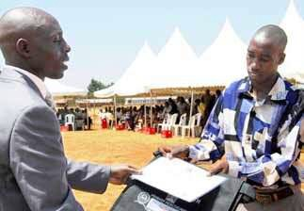
Working towards the aspect of inclusivity and representation within SDG 16, The Indiana University Center for Global Health (IUCGH) and the AMPATH Consortium is engaged with the Kenyan government in efforts to promote the accessibility of national health insurance coverage for Kenyan citizens. For many families in western Kenya, the biggest barrier to better health is obtaining the proof of identification needed to enroll in Kenya’s national insurance program. AMPATH’s Population Health Model recognizes the crucial intersection of health and socioeconomic factors. It acknowledges and addresses the impact that
individual, interpersonal, organizational, community, and public policy factors often have directly or indirectly on health access and care.

The national insurer, NHIF, provides a comprehensive health cover for informal sector households at a monthly cost of KSH 500 (about $5 USD) and covers outpatient and inpatient services. The requirements for enrolling individual household members include possessing a national identity card for family members over 18 years, a marriage certificate to prove spousal relationship, and birth certificates for children under the age of 18.

AMPATH has teamed up with the county government in Busia for a pilot effort to help ensure that all residents of Bunyala have the proper documents to enable them to enroll in NHIF. AMPATH has worked with the separate functions of civic registration and the offices of registration of birth and deaths (i.e. vital statistics) to ensure that households are prepared to apply for IDs and birth certificates. The Consortium has also assisted by bringing these services closer to residents, providing them alongside outreach and clinical services. Working with the local administration, the first step was to understand the gaps in the region by determining the number of individuals who:

- had attained the age of 18 years and had no national IDs or had lost them,
- or were less than 18 years of age and lacked birth certificates.

The next steps include the application and verifications as per the public policy.

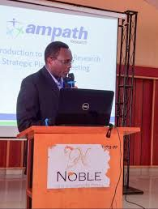
Partnership support is being sought to help households that cannot afford to pay for registration documents because they are often the ones that need financial risk protection the most in the form of health insurance. These efforts are not only important for health insurance enrollment – they will serve multiple purposes for households that often require identification to access necessary public services, such as registration for their children’s education. These documents are important elements to a person’s identification as a basic human right.³⁸

SDG 17
SDG 17 aims to promote global partnerships in order to achieve the 17 SDGs by 2030. Officially, this goal requires strengthening the means of implementation and revitalize the global partnerships necessary for sustainable development. on

achieving peace, justice, and strong governance institutions around the world. The main target of SDG 17 is strengthening domestic resource mobilization – including international support to developing countries – to improve domestic capacity for tax and other revenue collection. Key targets in achieving this goal are the adoption and implementation of investment regimes for developing nations and the enhancement of North-South, South- South, and triangular regional and international cooperation.

AMPATH – a global network of academic health centers collaborating with ministries of health in low and middle- income countries to ensure essential health care for all – is centrally positioned to contribute to the achievement of SDG 17.

The Academic Model Providing Access to Healthcare (AMPATH) began in 1990 as a partnership between Indiana University and Moi University in Eldoret, Kenya, and has since evolved into an alliance between Moi Teaching and Referral Hospital (MTRH), Moi University (MU) and a consortium of academic health centers around the world (the AMPATH Consortium) led by Indiana University.
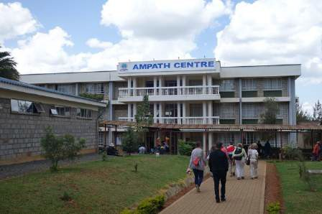
In addition to Indiana University, the AMPATH Consortium currently includes (in alphabetical order): Brown University; Duke University; Johns Hopkins; Mount Sinai; New York University; Purdue University; Stanford University; University of Alberta; University of California, San Francisco; University of Texas at Austin; and University of Toronto.
For three decades, AMPATH has generated mutually beneficial outcomes for all partners in health care delivery, research and training. Working together, the partnership has improved the health of individuals and their communities in Kenya, North America, and beyond. Participants have learned
hard lessons and refined the model through collaborative, integrated study with Kenyan partners. AMPATH has developed a strong and replicable model that creates sustainable and long-term change from within the existing institutions of public sector health systems.³⁹

1 See www.ampathkenya.org.
2 See https://sdgs.un.org/goals.
3 See McIntosh, I. and E. Kamaara. (2016) “AMPATH: A Strategic Partnership in Kenya.” Global Perspectives on Strategic International Partnerships. Institute of International Education. Available at SSRN: https://ssrn.com/abstract=2768205. 4 See https://www.un.org/sustainabledevelopment/health/.

5 See Ruhl L., et al. (2015). “AfyaJamii: Introducing a Group Prenatal and Postnatal Care Models in Kenya.” Annuals of Global Health. 81 (1): 199; Maldonado, LY., et al. (2020). “Promoting Positive Maternal, Newborn, and Child Health Behaviors through a Group-based Health Education and Microfinance Program: A Prospective Matched Cohort Study in Western Kenya.” BMC Pregnancy Childbirth. 20 (1): 288; Esamai F., et al. (2017). “A Systems Approach to Improving Maternal and Child Health Care Delivery in Kenya: Innovations at the community and Primary Care Facilities.” Reproof Health. 14 (1): 105.
6 See https://www.ampathkenya.org/news-blog-feed/2019/11/14/maternal-fetal-medicine-fellowship-improving-care- for-sick-moms-and-babies
7 See Christoffersen-Deb, A., et al. (2015). “Chamas for Change: An Integrated Community-based Strategy of Peer Support in Pregnancy and Infancy in Kenya.” The Lancet Global Health. 3: S22 and https://www.ampathkenya.org/news- blog-feed/2021/1/26/research-shows-positive-impact-of-groups-for-pregnant-mothers
8 See https://www.regenstrief.org/article/wecare-care-programs-help-lower-indiana-infant- mortality/#:~:text=Preliminary%20data%20released%20by%20the,2018%20to%206.4%20in%202019.
9 See https://medicine.iu.edu/expertise/indiana-health/opioid-crisis/care-plus.
10 See https://addictions.iu.edu/news/community-health-workers.html.
11 See Bucher S., et al. (2020). “Digital Health Innovations, Tools, and Resources to Support Helping Babies Survive Programs.” Pediatrics. Oct 2020. 146 (Suppl2): S165-S182. And, Umoren, R.A., et al. (2020). “Mobile Virtual Reality Provider Training in Helping Babies Breathe.” Pediatrics. 146 (1 Meeting Abstract): 290; Umoren R.A., et al. (2020). “Pre-Training Cognitive and Psychomotor Gaps in Healthcare Worker Neonatal Resuscitation Skills for Helping Babies Breathe – A Report from the eHBB/mHBS Study.” Pediatrics. 146 (1 Meeting Abstract): 378; and McHenry M., et al. (2019). “Interventions for Developmental Delays in Children Born to HIV-infected Mothers: A Systematic Review.” AIDS Care. 31 (3): 275-82.
12 See Mamlin, J., et al. (2004). “Academic Institutions Linking Access to Treatment and Prevention.” Geneva: World Health Organization. https://www.who.int/hiv/pub/prev_care/en/ampath.pdf
13 See https://www.ampathkenya.org/history.
14 See Loehrer Sr., P.J., et al. (2018). “Capacity Building in sub-Saharan Africa: Models of Care.” The Lancet Global Health: S17-
18. DOI: https://doi.org/10.1016/S2214-109X(18)30090-1.
15 Personal Communication with Naftali Busakhala (Head of Department Moi Teaching and Referral Hospital Department of Oncology)about the ABCCCP project.
16 See Chit Asirwa, F., et al. (2016). “Medical Education and Training: Building In-Country Capacity at All Levels.” Journal of Clinical Oncology. 34 (1): 36-42. And, Cornetta, K., et al. (2015). “Integration of Palliative Care Into Comprehensive Cancer Treatment at Moi Teaching and Referral Hospital in Western Kenya.” Journal of Global Oncology. 1 (1): 23-29.
17 See Strother, R. M., et al. (2012). “The Oncology Pharmacy in Cancer Care Delivery in a Resource-Constrained Setting in Western Kenya.” Journal of Oncological Pharmaceutical Practice. 18 (4): 406-16.
18 See The Ampath Medical Record System (AMRS) Database.
19 See Kwobah, E., et al. (2017). “Prevalence of Psychiatric Morbidity in a Community Sample in Western Kenya.” BMC Psychiatry. 18 Jan 2017. 17 (1): 30. And, Kwobah, E., et al. (2020). Step-wise Development of Primary Care and Community- based Mental Health Care in a low resource setting: A Community Case Study of Rural Western Kenya. In S. Okpaku (ed.), Innovations in Global Mental Health. Springer International Publishing; Global Health Progress: Collaborating for a Sustainable Future. Astellas Global Health Foundation/AMPATH. https://globalhealthprogress.org/collaboration/astellas- global-health-foundation-ampath/.
20 See Lancaster, K. E., et al. (2018). “Substance Use and Universal Access to HIV Testing and Treatment in Sub-Saharan Africa: Implications and Research Priorities. Journal of Virus Eradication. 15 Nov 2018. 4 (Suppl 2): 26-32. And, Kinyanjui D. W. and L. Atwoli. (2013). “Substance Use Among Inmates at the Eldoret Prison in Western Kenya.” BMC Psychiatry. 13 Feb 2013. 13: 53; Embleton, L. et al. (2013). “The Journey of Addiction: Barriers to and Facilitators of Drug Use Cessation Among Street Children and Youths in Western Kenya.” PLoS One. 8 (1).
21 See Papas, R.K., et al. (2020). “A Randomized Clinical Trial of a Group Cognitive-Behavioral Therapy to Reduce Alcohol Use Among Human Immunodeficiency Virus-infected Outpatients in Western Kenya. Addiction. 18 May 2020. 10. And, Jaguga, F. (2020). A Review of the Public Sector Substance Use Disorder Treatment and Prevention Systems in Kenya.” Substance Abuse Treatment Prevention Policy. 20 Jul 2020. 15 (1): 47.
22 See Bernard, C., et al. (2018). “Integration of Contraceptive Services into Anticoagulation Management Services Improves Access to Long-acting Reversible Contraception.” Contraception. 98 (6): 486-491. And, Millar H. C., et al. (2020). “Decreasing

Incidence of Pregnancy Among HIV-positive Adolescents in a Large HIV Treatment Program in western Kenya between 2005 and 2017: A Retrospective Cohort Study. Reproductive Health. 17 (1): 191; MacDonald K.R., et al. (2016). “The Confluence of Pregnancy and New Diagnosis of HIV Among Adolescent Women in Western Kenya.” Journal of Adolescent Health. 60 (2): S83-S4.
23 See Were, L., et al. (2020). “Effects of Social Health Insurance on Access and Utilization of Obstetric Health Services: Results from HIV+ Pregnant Women in Kenya.” BMC Public Health. 20 (1): 87. And, Were, M. C., et al. (2020). “Coverage of IMIA-recommended Competencies by Masters in Health Informatics Degree Programs in East Africa”. International Journal of Medical Information. 143: 104-265.
24 See Tran, D. N., et al, (2020). “Solving the Problem of Access to Cardiovascular Medicines: Revolving Fund Pharmacy Models in Rural Western Kenya.” BMJ Global Health. 5 (11). And, Pastakia, S. D., et al. (2012). “Collaborative Partnership for Clinical Pharmacy Services in Kenya.” American Journal of Health Systems. 66 (15): 1386-1390; Strother,
R. M., et al. (2012). “The Oncology Pharmacy in Cancer Care Delivery in a Resource-constrained Setting in Western Kenya.” Journal of Oncology Pharmaceutical Practice.
25 See Global Air Quality Trekkers--Nandi Clean Kitchen Study from Purdue (https://docs.lib.purdue.edu/pjsl/vol7/iss1/19/). And, Agarwal, A., et al. (2018). “Household Air Pollution is Associated with Altered Cardiac Function Among Women in Kenya.” American Journal of Respiratory and Critical Care Medicine. 197 (7): 958-961; Bloomfield, G. S., et al. (2019). “Effects of a Cookstove Intervention on Cardiac Structure, Cardiac Function, and Blood Pressure in Western Kenya.” Journal of the American Society of Echocardiography. 32 (3): 427-430.
26 AMPATH Nandi Improved Kitchens: https://www.ampathkenya.org/news-blog-feed/2019/11/8/tackling-indoor-air- pollution-the-story-of-nandi-improved-kitchen-designs
27 See Tran, D. N., et al. (2017). Patient-centered Access to Cardiovascular Disease Medicines in Low-Income and Middle- Income Countries Through Health-System Strengthening.” Cardiology Clinics. 35 (1): 125-134. And, Tran D. N., et al. “Solving the Problem of Access to Cardiovascular Medicines: Revolving Fund Pharmacy Models in Rural Western Kenya.” BMJ Global Health. 5 (11); Pastakia, S., I. Manji, and T. Mercer (2015). “Noncommunicable Diseases And Essential Medicines.” Health Affairs. Project Hope. 34(11); Manji, I., et al. (2016). “The Revolving Fund Pharmacy Model: Backing up the Ministry of Health Supply Chain in Western Kenya.” The International Journal of Pharmacy Practice. 24 (5): 358-366.
28 See Christoffersen-Deb, A., et al. (2015). “Chamas for Change: An Integrated Community-based Strategy of Peer Support in Pregnancy and Infancy in Kenya. The Lancet Global Health. 3: S22. And, Umoren, R. A., et al. (2020). “Mobile Virtual Reality Provider Training in Helping Babies Breathe.” Pediatrics. 146: 290; Umoren, R. A., et al. (2020). “Pre-Training Cognitive and Psychomotor Gaps in Healthcare Worker Neonatal Resuscitation Skills for Helping Babies Breathe – A Report from the eHBB/mHBS Study.” Pediatrics. 146: 378.
29 See O’Neill, J. (2016). “Review on Antimicrobial Resistance: Tackling Drug-Resistant Infections Globally—Final Report and Recommendations.” UK Government: Wellcome Trust. (https://amr- review.org/sites/default/files/160518_Final%20paper_with%20cover.pdf). And, Dyar, O. J., et al. (2017). What is Antimicrobial Stewardship?” Clinical Microbiology Infection. 23: 793-798.
30 See Rosenberg, M., et al. (2020). “The Relationship between a Microfinance-based Healthcare Delivery Platform, Health Insurance Coverage, Health Screenings, and Disease Management in Rural Western Kenya.” BMC Health Serv Res. 20 (1): 868. See also, Corteva’s “Food by Prescription” (https://www.youtube.com/watch?v=OXA4IpNX6w8).
31 See Turissini,M., et al. (2020). “Developing Ethical and Sustainable Global Health Educational Exchanges for Clinical Trainees: Implementation and Lessons Learned from the 30-Year Academic Model Providing Access to Healthcare (AMPATH) Partnership.” Annuals of Global Health. 86 (1): 137.
32 See Claussen, S. A., et al. (2020). “An Innovative Model for Engineering Study Abroad in a Nontraditional Context: An Evaluation of Student and Community Outcomes.” Journal on Excellence in College Teaching. 30 (4): 121-156. And, Haney, C.L., et al. (2019). “Tumaini Tech Project: A Case Study of the Development of Engineering Self-Efficacy and Understandings of Engineering in Former "Street Youth" in Kenya.” In Proceedings of Eighth Research in Engineering Education Symposium, 858- 861, Cape Town, South Africa: Rees, 2019.
33 See Ott, M. A., et al. (2020). « Peers, Near-Peers, and Outreach Staff to Build Solidarity in Global HIV Research With Adolescents.” American Journal for Bioethics. 20 (5): 72-4.
34 See AMPATH Handwashing Stations. (https://www.ampathkenya.org/news-blog-feed/2020/8/28/covid-safety-measures- enabled-by-donors).
35 See Gardner, A (ed.). (2018). “The Many Ways Moi University, Moi Teaching and Referral Hospital, and The People of Kenya Benefit from the AMPATH Partnership.” IUCGH White Paper.

36 See Turissini, M., et al. (2020). « Developing Ethical and Sustainable Global Health Educational Exchanges for Clinical Trainees: Implementation and Lessons Learned from the 30-Year Academic Model Providing Access to Healthcare (AMPATH) Partnership.” Annuals of Global Health. 86 (1): 137.
37 See Tierney, W. M., et al. (2013). “These are good problems to have...: Establishing a Collaborative Research Partnership in East Africa.” Journal Internal Medicine. 28 (Suppl 3): S625-38. See also, Reciprocal Innovation Grants (https://globalhealth.iu.edu/news-events/_news/ctsi-reciprocal-innovation-grants-2021.html).
38 See National ID Cards (https://www.ampathkenya.org/news-blog-feed/2020/9/29/breaking-down-barriers-to-health-in- bunyala).
39 See Mercer, T., et al. “Leveraging the Power of Partnerships: Spreading the Vision for a Population Health Care Delivery Model in Western Kenya.” Global Health. 14 (1): 44. And, Johnson, M., et al. (2018). “Global Partnerships to Support Noncommunicable Disease Care in Low and Middle-Income Countries: Lessons from HIV/AIDS. Aids. 32: S75-S82; Karwa, R., et al. (2020). ”Evaluating the Impact of a 15-year Academic Partnership to Promote Sustainable Engagement, Education, and Scholarship in Global Health.” Journal of the American College of Clinical Pharmacy.

